Quick Guide: Spectral/Calibration Transfer

**Code:** PM – 002 / 1

**Version:** 2023. v1

**Related documents**

PM – 001/1 Model development for forages using NeoSpectra Instrument

PM – 005/1 Model Transfer – Workflow

Contents

**Introduction 1**

**Glossary 2**

**PREREQUISITES 2**

**SUPPORT 2**

**PROCEDURE 3**

SAMPLE PREPARATION AND COLLECTION OF TRANSFER SAMPLES 3

PREPARING THE SPECTRAL DATABASE 3

CREATING THE TRANSFER METHOD/FUNCTION 3

PREPARING THE DATA (SOLO+Exporter) 3

Average spectra? 4

CREATING THE TRANSFER METHOD/FUNCTION 5

SAVING THE TRANSFER METHOD 12

USING A TRANSFER METHOD/FUNCTION 13

# Introduction

This SOP will guide you through the process of creating a transfer method that can be used to adapt the spectra from other manufacturers' instruments to those collected using Si-Ware spectrometers. The instrumentation used to collect the spectra can be of any design (FT-based or Monochromator/Dispersive based) that includes a shared wavelength region with native Si-Ware/Neospectra data. In this document, we will refer to the **Si-Ware instrument as Instrument 1***(as denoted in Eigenvector Solo software)* and the other instrument on which we wish to apply the transfer function as Instrument 2

# Glossary

*Labstore:* Website where the models can be commercialized like a marketplace.

*Portal:* Cloud based website where samples, models, user,.. are managed by Si-Ware’s accounts. Portal gives access to the Labstore and all the data and information generated from the NeoSpectra instruments.

*Instrument:* It is the spectrometer; it can also be referred to as the unit or scanner. It is the hardware used to collect NIR spectra.

*Model:* It is the mathematical algorithm used to correlate some data to a parameter or to spectra.

*Samples:* These are the elements of the observation that are used to develop models. Samples are related to the matrix/product/material that is analyzed by the Scanner and it is intended to obtain information by using models.

*Calibration:* it is the part of the process where the model is developed and trained. It is related to calibration samples, model calibration,…

# PREREQUISITES

* Each sample type (material) requires its own transfer model/function (it may be possible for multiple materials which have very similar spectra/properties).
* Samples must be scanned on both instruments on the same day. Transfer samples for instrument 2 should be measured using the same setting that the calibration samples were measured. Instrument 1 measurements should be done as it is wished to measure using NeoSpectra devices under the same operating conditions.
* The Sample sets used for the transfer should ideally encompass all possible variations in the calibration sample set. (i.e., concentrations of main components over the calibration ranges of each calibration).
* Sample set upon which to apply the transfer function.

# SUPPORT

If any assistance is needed or if you have any questions regarding the use of this procedure, please contact one the applications team at [modeling@si-ware.com](mailto:modeling@si-ware.com)

# PROCEDURE

The procedure is broken down into 3 parts: Sample preparation and collection of transfer samples; creating the transfer method/function; applying the transfer function to a spectral data set.

## SAMPLE PREPARATION AND COLLECTION OF TRANSFER SAMPLES

**15 to 20 samples that cover the complete range of all components (**i.e., fat, moisture, protein) to be analyzed will be needed to create the transfer function.  **It is essential to measure the same transfer samples on both instruments on the same day.** Ideally, all samples should be measured at the same time and in the same location with both instruments in a manner that reflects the original sampling protocol in order to prevent altering the presentation or sample condition when transferring samples. This will help to ensure that any outside factors are eliminated and only the spectral differences of the spectrometers are being compared. Additionally, when collecting samples, the samples should be named and numbered identically, so it is easy to match up and be imported in the same order when creating the transfer function.

## PREPARE THE SPECTRAL DATA BASE

The data from Instrument 2 has to be prepared in an excel file by exporting the data from the original instrument software. It is important to ensure that the parameters are integrated in the excel file (i.e. ensure that the spectra has the components/parameters, protein, moisture, NDF, trans-fats,… in the same order than the spectra before transfer, to later be added for the PLSr parameter calibration).

## CREATING THE TRANSFER METHOD/FUNCTION

There are two ways to transfer the spectra, one is using Solo+Exporter software from Eigenvector (presented here), and the second is using a Si-Ware Web Application.



## PREPARING THE DATA (SOLO+Exporter)

In order to be able to begin the transfer process, the calibration spectra from Instrument 2 will need to be exported from the Native software (i.e., NIRware/NirCal - Buchi, OPUS - Bruker) and converted into a csv file for importing into the transfer program. Eigenvector solo has the capability to import most Native instrument spectral formats, as well as text files. To simplify the transfer process, it is best to standardize the input files in the form of a CSV file with the Sample Name/Number in the first column, the x-axis on the first row and the associated Y values for each sample in their corresponding columns.

***Careful consideration MUST be made when creating both files such that each file from each instrument is both in the same order numerically AND the x-axis is oriented in the same direction.***

Once you have the data from each instrument in its own CSV file format and named appropriately (I.e., Instrument 1_ProductDescription_TransferSet_Date), you can then move on to creating the transfer function.

## Average spectra?

Neospectra, Instrument 1, spectra should always have several measurements per sample. These then need to be averaged to have a single spectrum per sample. This operation can be done in the Solo software once the spectra file is uploaded. Double-click on the matrix, select Transform, Coadd data Reduction.

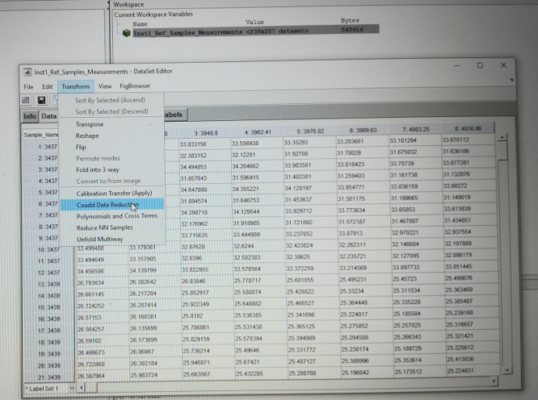

A pop-up with the setting will appear. Select the number of measurements done per sample (in the example 12 measurements per sample) and change action to mean. Reduction should be done in the rows direction (as per default).

## CREATING THE TRANSFER METHOD/FUNCTION

*IMPORTANT: Before you begin creating a transfer method in Eigenvector Solo, you must make one very important change. We need to change the maximum number of Principal Components (PCs) used by the Piecewise Direct Standardization (PDS) algorithm to a max of 1. The max PCs may be set from the home workspace windowvia *Edit => Options => Preferences* and search for the function***stdgen*** the default value is empty [ ], which then is interpreted to be the number of samples. Reducing the number of PCs to 1 effectively and reliably eliminates any "spikey" behaviors in the calibration transfer process. \**(it should be noted, that occasionally it will be useful to use more than one PC, but for the majority of the cases, one should suffice.)*

Upon clicking on *Preferences* you may receive the following prompt:

Select “ok” to continue.

In the resulting window type in “stdgen” and click on view options as shown below.

From here, you will want to click on the “maxpc” line under “option” and change the override value to 1 by clicking *set*, then *ok* as illustrated below.

You can now move on to setting up the transfer method by double clicking on “calibration transfer” under the “TRANSFORM” menu in your solo workspace browser.

Once loaded in, you will be presented with the calibration transfer GUI. You will first need to load your datasets from Instrument 1 and 2 using the load buttons corresponding to each instrument (as shown) followed by selecting “PDS” under the “model construction” section (as shown).

After selecting PDS, you will also need to change the window size under the “parameters” section of GUI as shown. A window size of 3 should work for most applications.

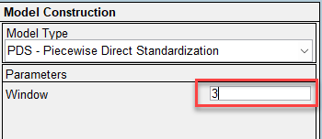

Once you have your parameters set, you can initiate the creation of the transfer function by clicking on the “calculate” button

Once you have performed the calculation you can check the performance of the transfer function by looking at several metrics: The calculated difference (which shows the mean difference between the transferred spectra and the spectra from instrument 1.).

Or visually by selecting a variety of options when clicking on the “Plots” button.

Visually the transferred spectra should look smooth (without any jagged peaks or blips), and ideally, closely match those of Instrument 1.

An example of a bad transfer (which can be caused by a windows size that is too large, or too many pcs being used) is shown below.

For a transfer function to be successful the differences between instrument 1 and 2 should be minimal. B y selecting “difference spectra” from the “plots” menu, you are able to look at the post transfer difference between the transferred spectra and Instrument 1 to verify if you need to make any changes to your transfer. Ideally, the difference range for difference spectra should be between 0 and 0.04 absorbance units, though it may be slightly more variable for inhomogeneous samples than for ground samples.

## SAVING THE TRANSFER METHOD

If you are satisfied with the results of your transfer method, you must first save it via flat file or workspace before it can be applied to a data set. To save the file you **must use** the file menu on the “calibration transfer” window. From the file menu, click “save model”, you will then need to supply a name and click save. *(The default save location is in the workspace, but you can save to your computer's file system by selecting “file” in the save model dialog box)*

Once you have saved your file, you can exit the calibration transfer window and move on to applying the transfer method to a dataset.

## USING A TRANSFER METHOD/FUNCTION

In order to use the method you have just created, you will need to load (if you have not done so already) the dataset into your Solo Workspace, along with your transfer method.

To initiate the transfer, simply drag the dataset you wish to transfer onto the method in the workspace browser.

After saving your data set, you can then work with it directly in Solo, or you can choose to export it to a format of your choice by right clicking on the file.

